CSA1555-Cloud Computing and Big Data Analytics for Education.

Vanga Pranitha

Reg no:192111066

**LAB ACTIVITY-DAY3**

**EXPNO 4: CREATE A SNAPSHOT AND CLONING OF A VM AND TEST IT BY**

**LOADING THE PREVIOUS VERSION/CLONED VM**

AIM:To create a snapshot and cloning of a VM and test it by loading the previous version/cloned VM.

PROCEDURE:

**IMPLEMENTATION:**

**STEP 1: GOTO VMWARE WORKSTATION**

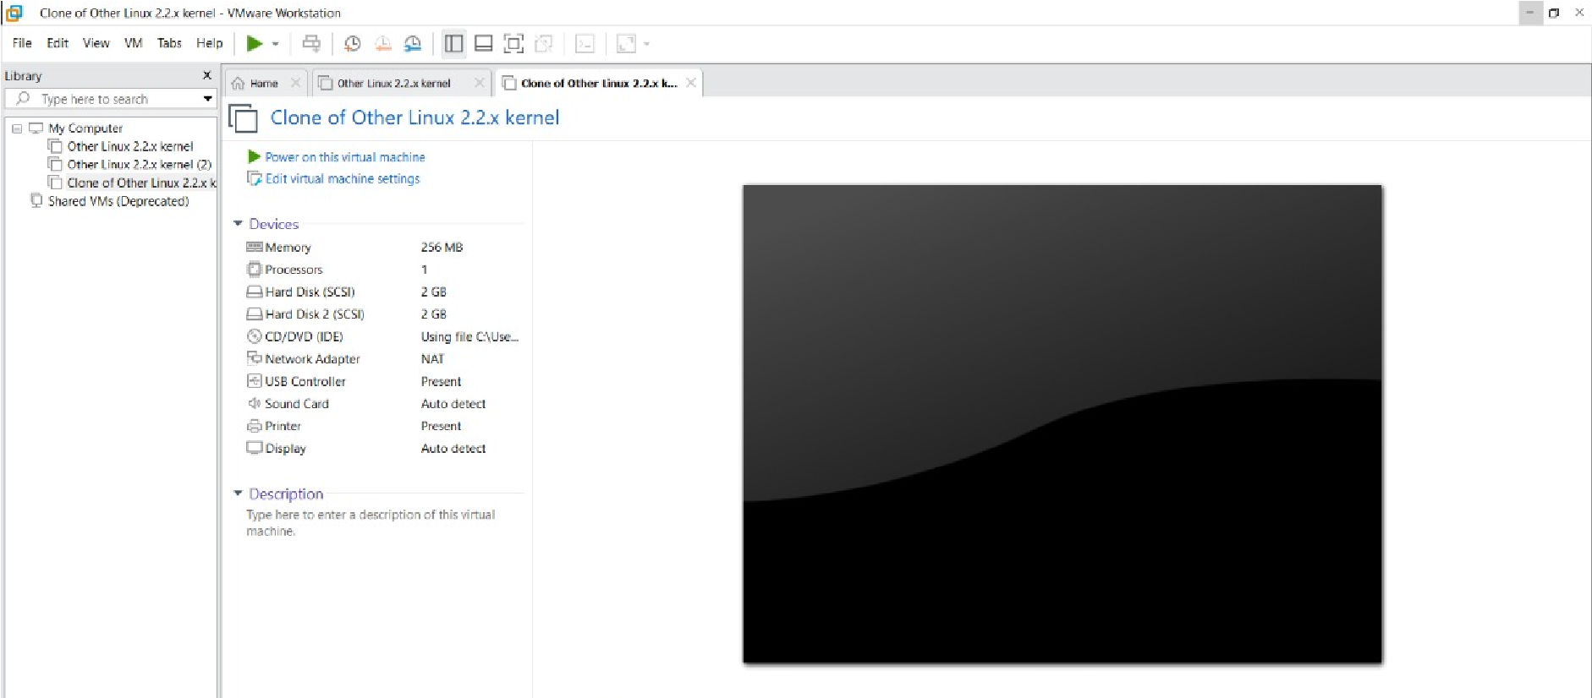 **STEP 2: CREATE FILES ON DESKTOP**

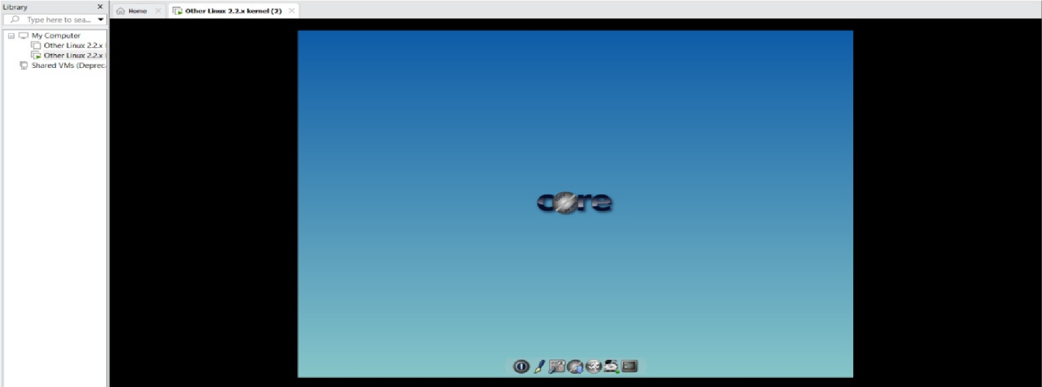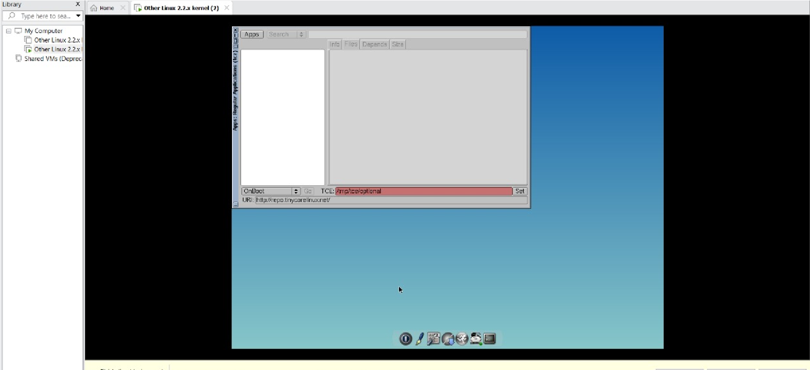 **STEP 2: CLICK ON VM AND SELECTS SNAPSHOT-> TAKE SNAPSHOT.**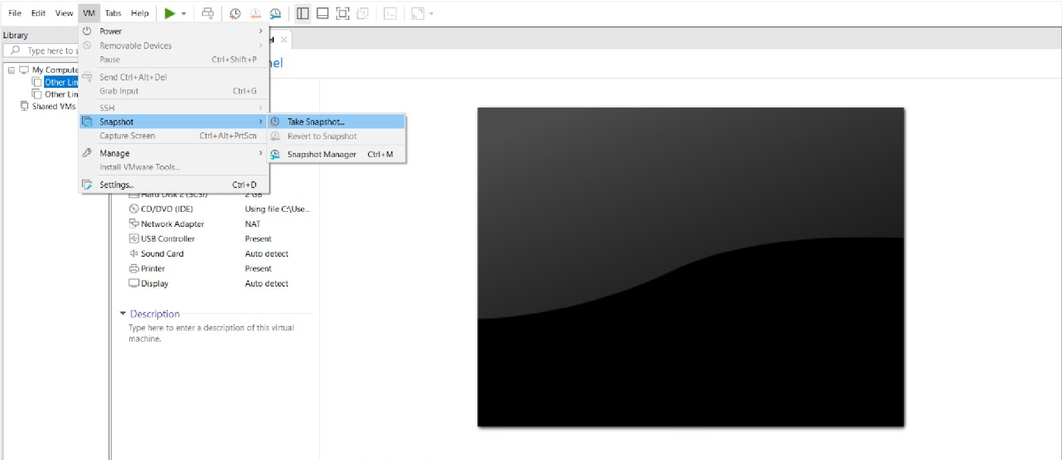

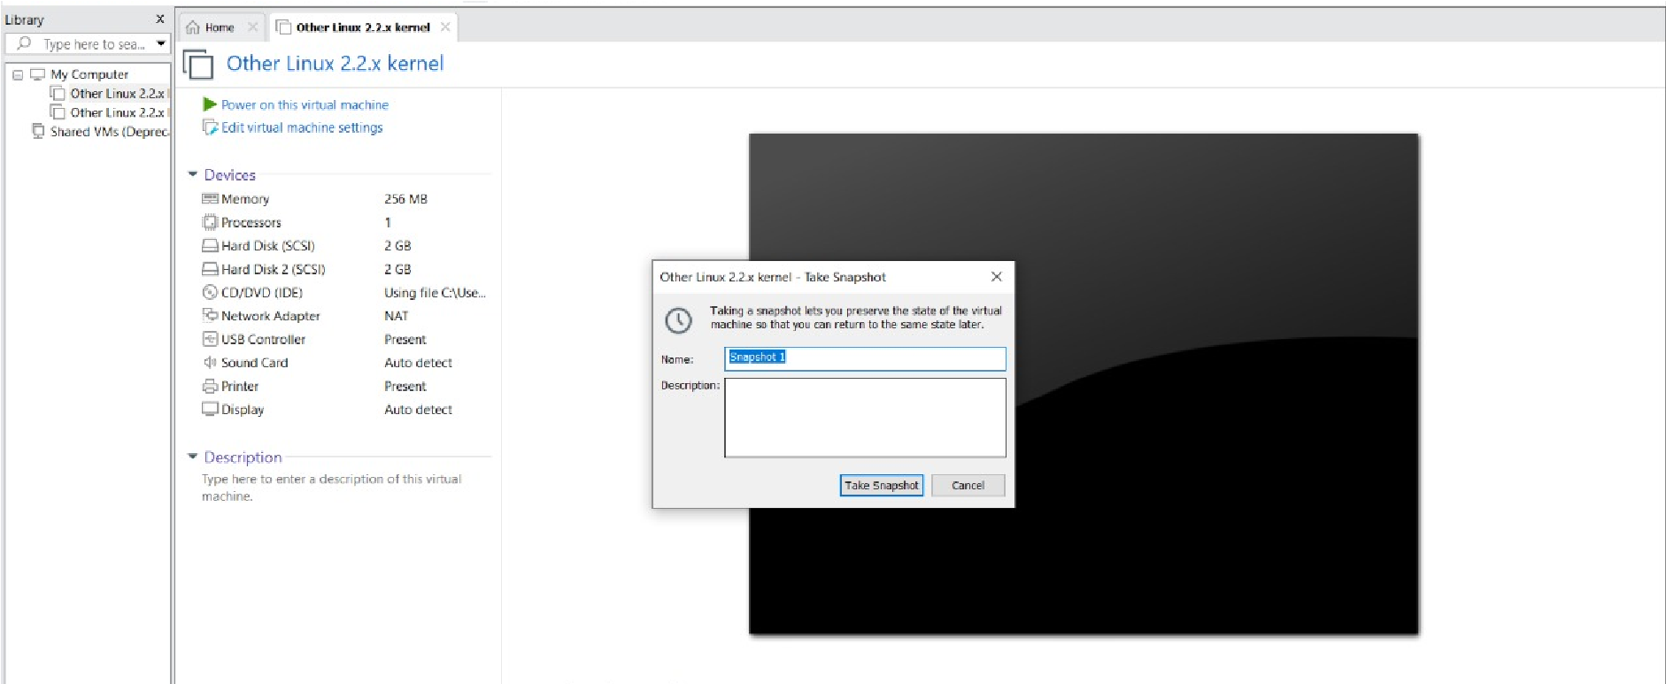 **STEP 4: SNAPSHOT IS BEING DONE**

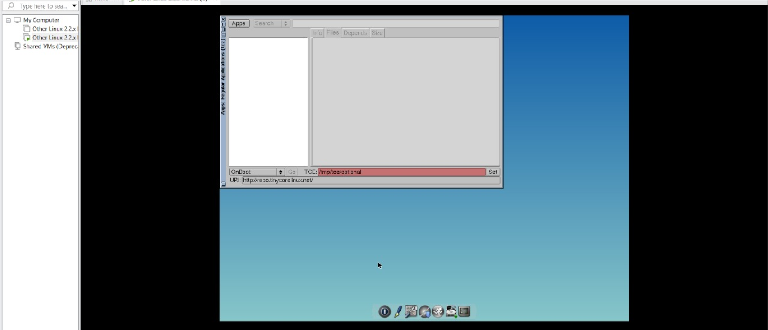 **CLONING OF A VM**

**STEP 1: GO TO VM AND GOTO MANAGE AND CLICK CLONE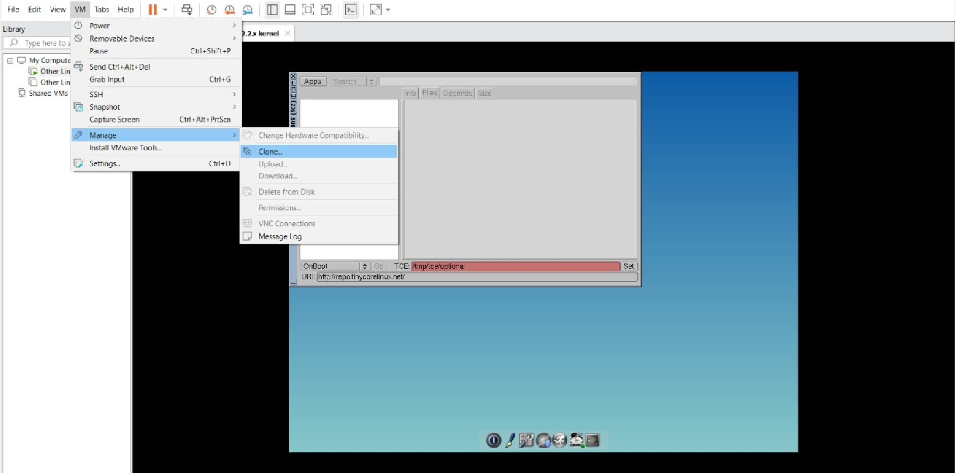 STEP 2: CLICK CLONE**

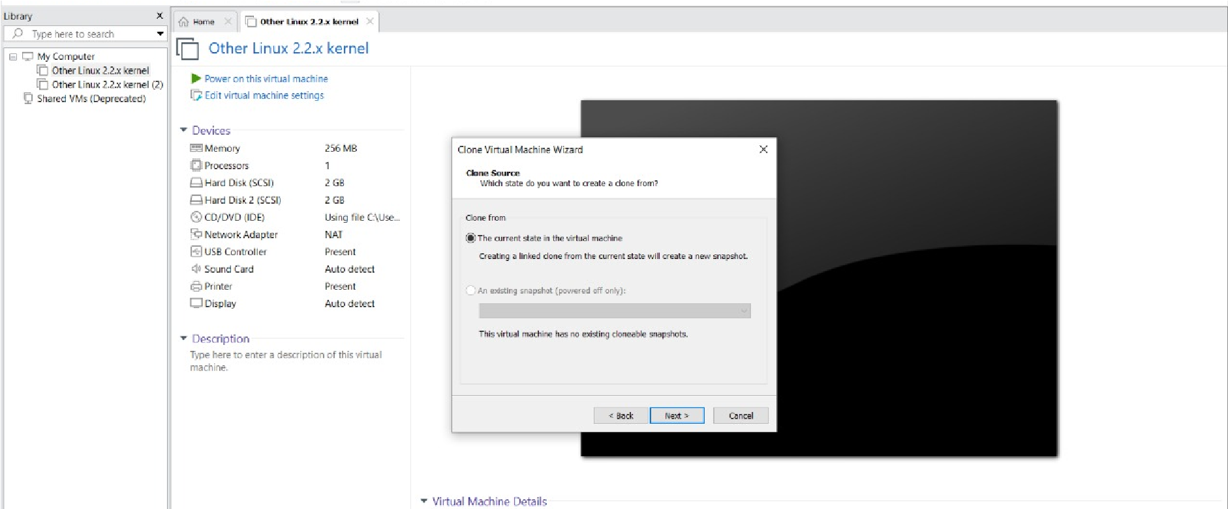

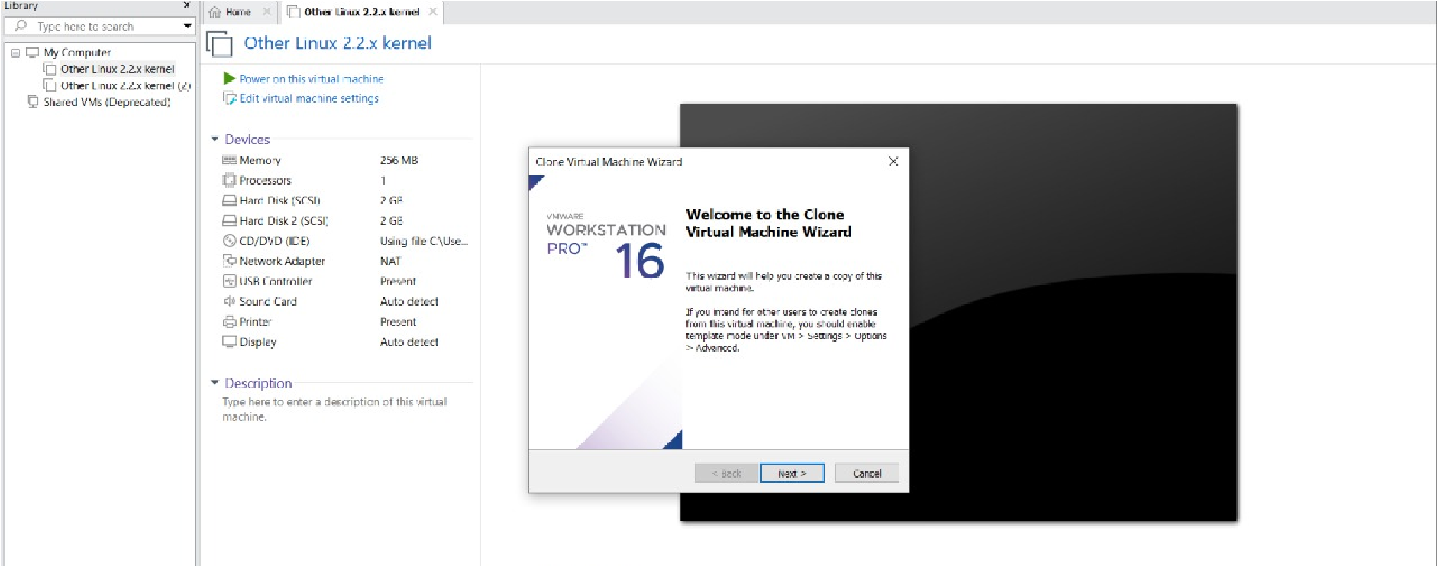 **STEP 3: SELECT THE FULL CLONE**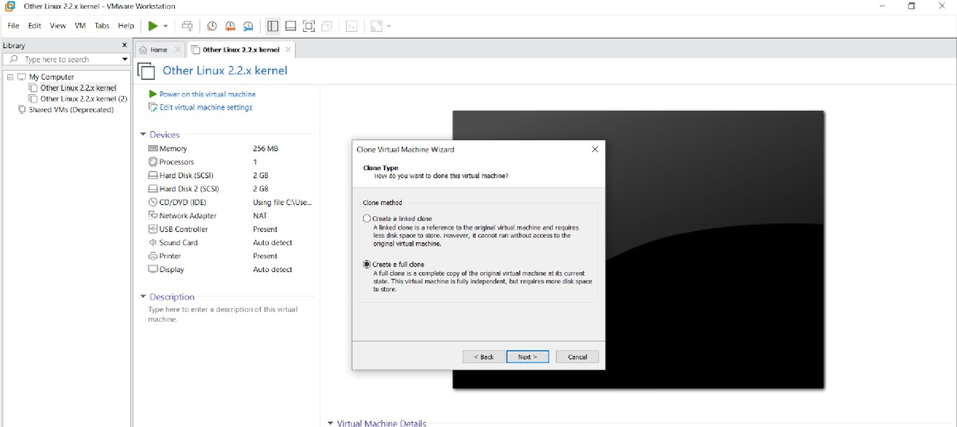

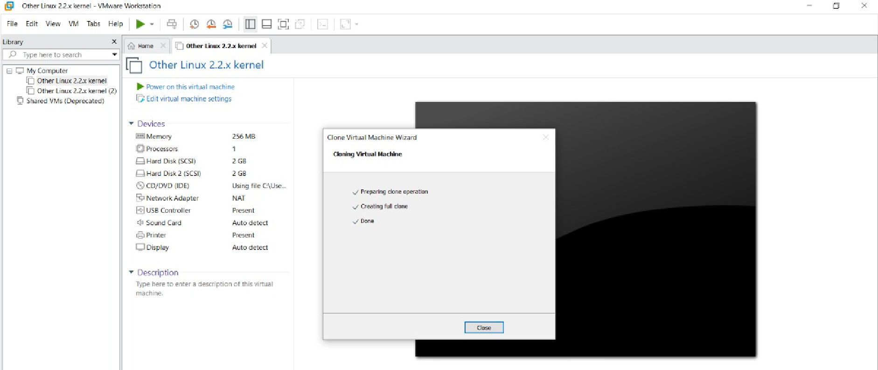 **STEP 4: AFTER CLONE AGAIN OR VM IS OPENED.**

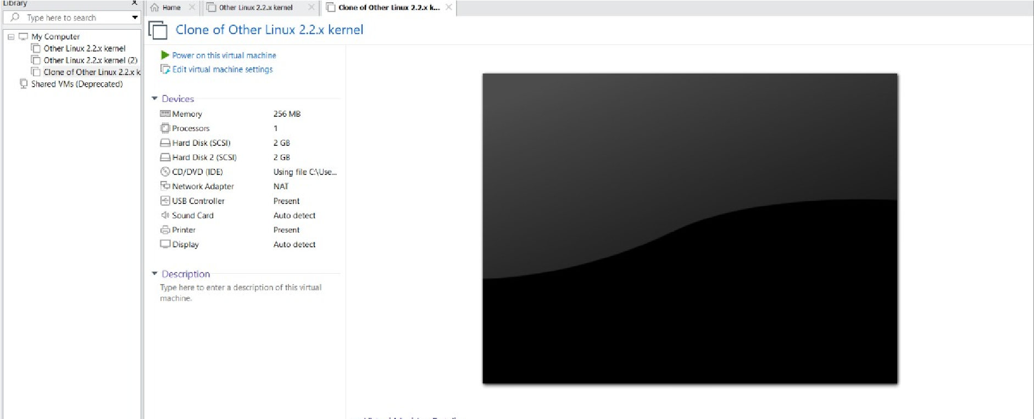

RESULT:A Snapshot is being created and cloning of a VM and testing it is done successfully.

**5.DEMONSTRATE INFRASTRUCTURE AS A SERVICE(IAAS) BY CREATING A VIRTUAL MACHINE USING A PUBLIC CLOUD SERVICE**

**PROVIDER(AZURE/GCP/AWS) CONFIGURE WITH MINIMUM CPU,RAM AND STORAGE AND LAUNCH THE VM IMAGE.**

PROCEDURE:

**Implementation:**

**STEP1:CREATE AN ACCOUNT IN MICROSOFT AZURE.**

**STEP2: GOTO RESOURCE GROUP AND CREATE A RESOURCE GROUP.**

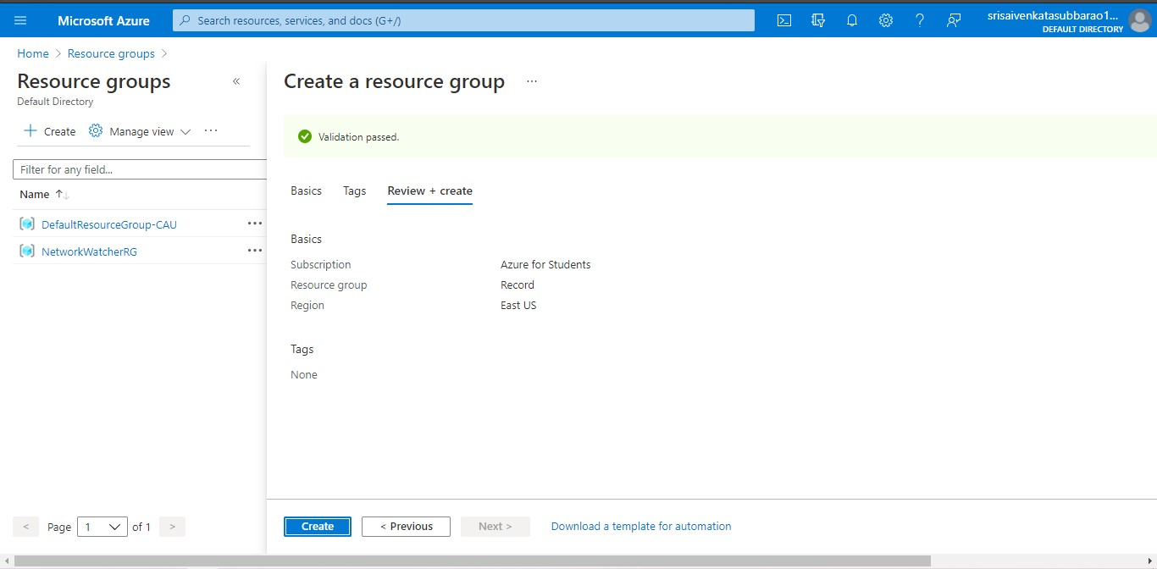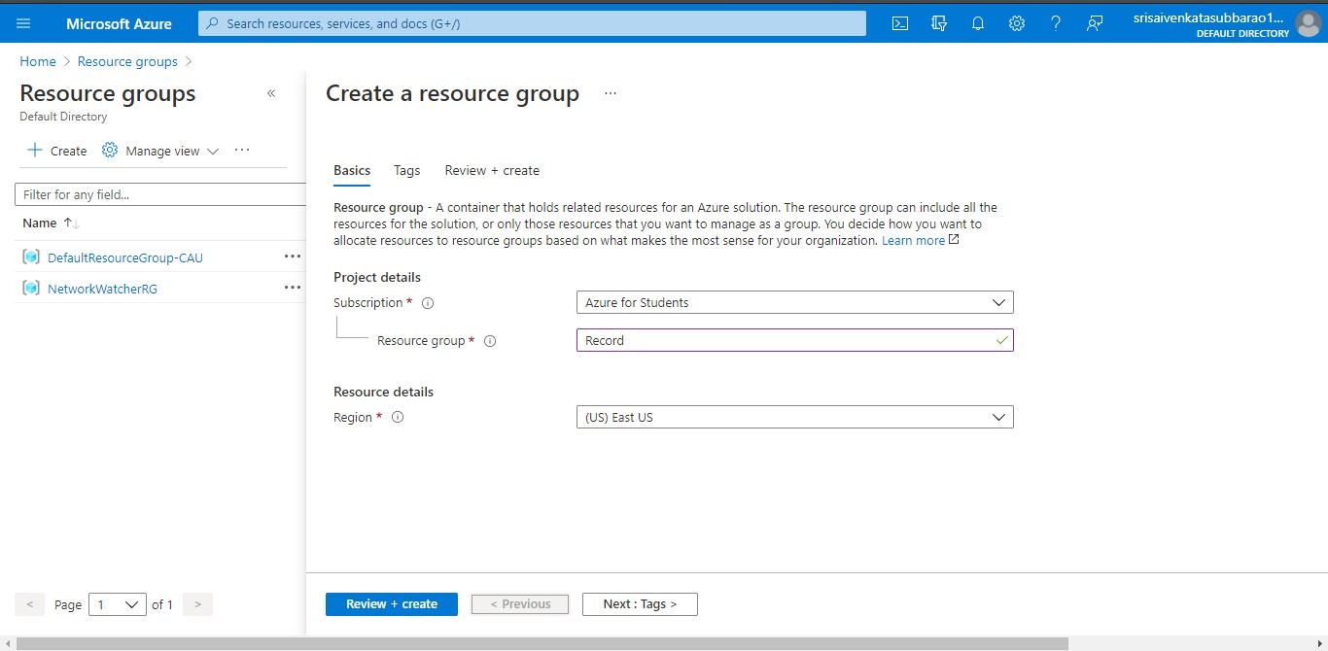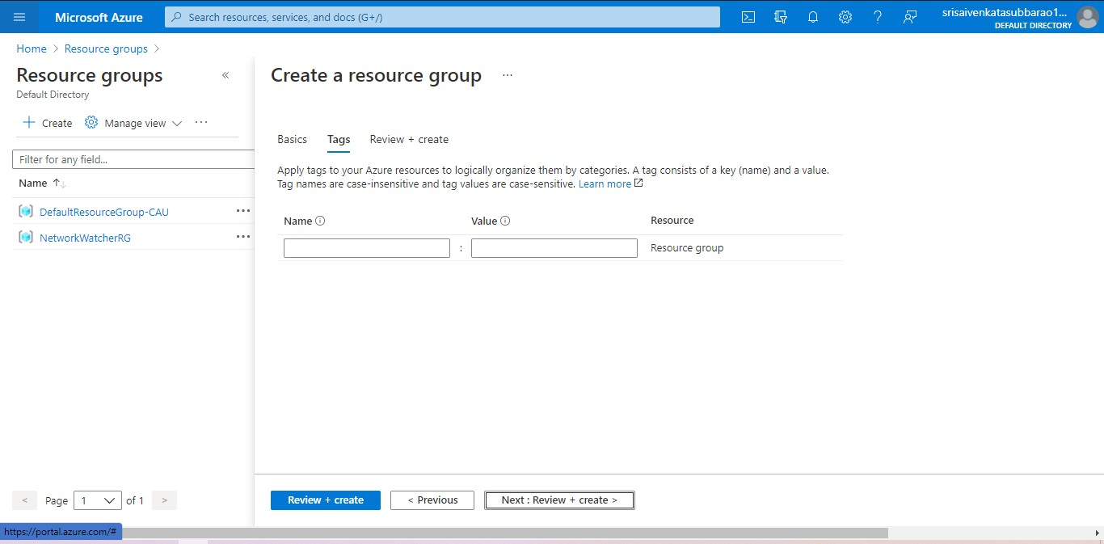 **STEP4: CREATE A VIRTUAL NETWORK FOR TO CREATE A VIRTUAL MACHINE .**

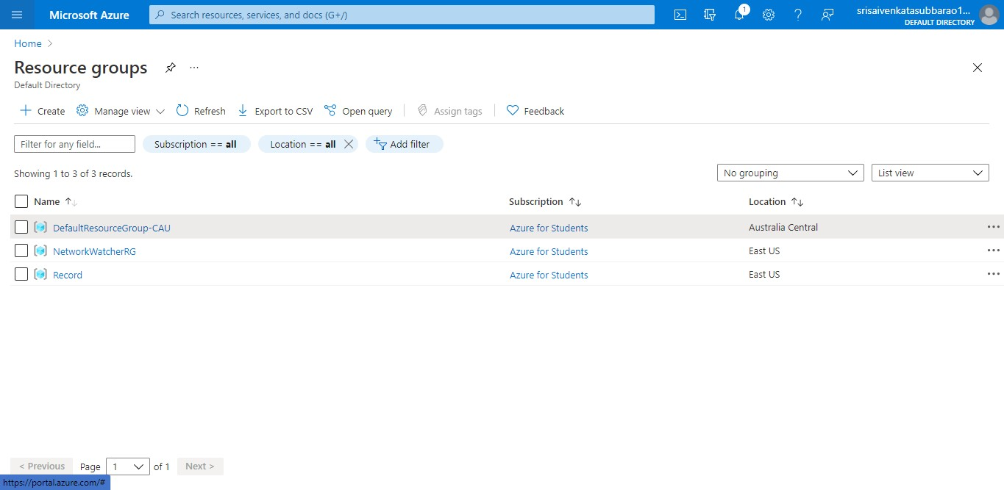 **STEP5: NOW CREATE A VIRTUAL MACHINE WITH UR IP ADDRESS AN USERNAME AND PASSWORD FOR YOUR VIRTUAL MACINE.**

**STEP6: AND YOUR VIRTUAL MACHINE IS DEPLOYED.**

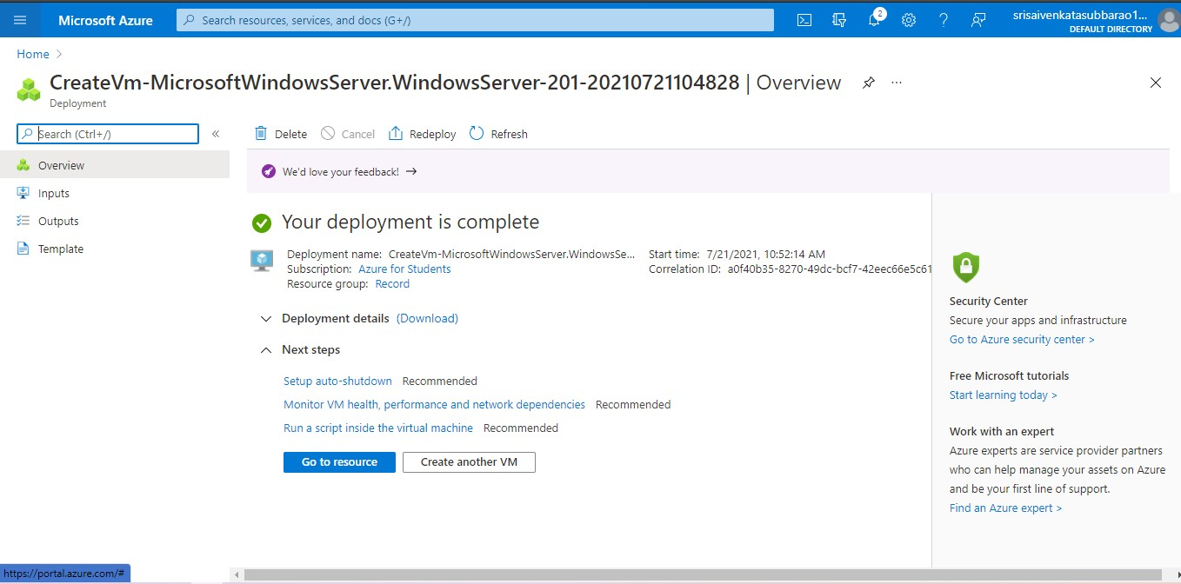 **STEP7: NOW CONNECT THE VIRTUAL MACHINE AND DOWNLOAD THE RDP FILE TO OPEN YOUR WINDOWS VIRTUAL MACHINE.**

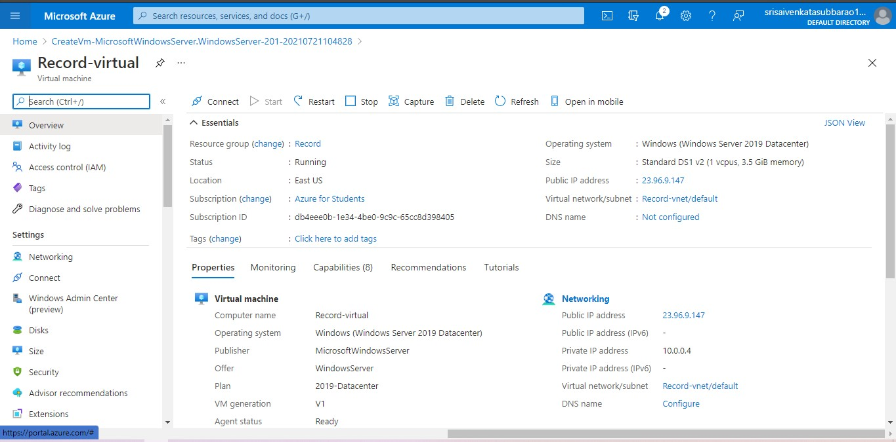 **STEP8: CREATED A NEW WINDOWS VIRTUAL MACHINE.**

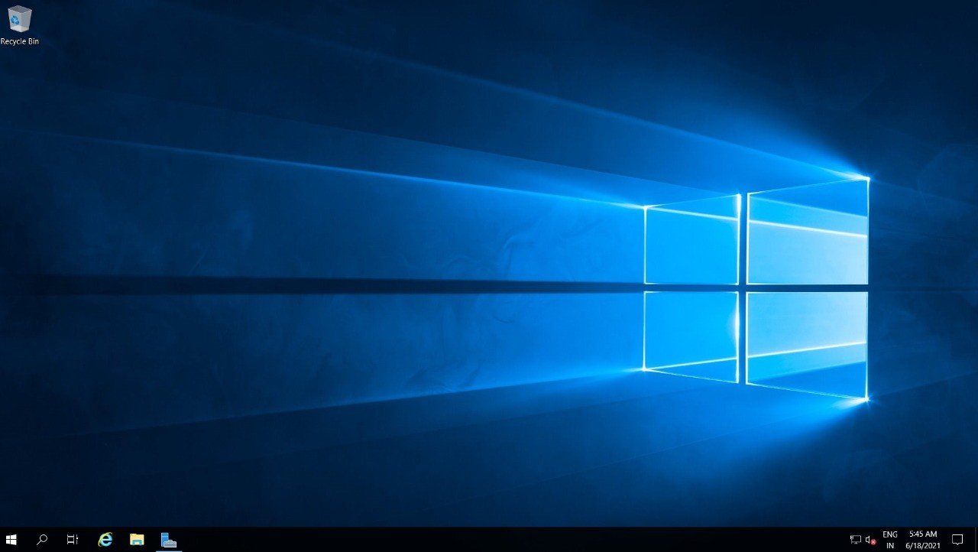

RESULT:to demonstrate iaas by creating a virtual machine using public cloud service.